Only the following webinar recordings are eligible at a discounted rate:
- RFP Scope of Work: Strategies for Success
- RFP Different but not Difficult 2.0
- Sailing the 7 Cs to Successful Scope of Work Design
- Procurement's Role in Cyber Security
- Federal Grants: A Top-Level Primer for Public Procurement Professionals
- Procurement's Role in the Use of Non-Emergency Federal Funds
- Reverse Auctions: A Powerful Negotiation Tool for Your Toolbox
- Value Beyond Price
- A Beginner’s Guide to Writing Specifications for Service Solicitations
- Bonding: The Good, The Bad, And the Ugly. Everything You Wanted to Know About Surety Bonds, but were Afraid to Ask
- Protest Proofing Your Specifications and Scopes of Work
- Safeguarding Your Procurement Process from Collusion & Criminal Antitrust Risks
- Technology Impacts in Procurement & Supply Chain
- Developing a Sustainable Purchasing Program: Embedding Sustainable Considerations and Best Practices into Procurement

How to register and access NIGP webinar recordings
- Navigate to www.nigp.org and click “Login” at the top of the page.
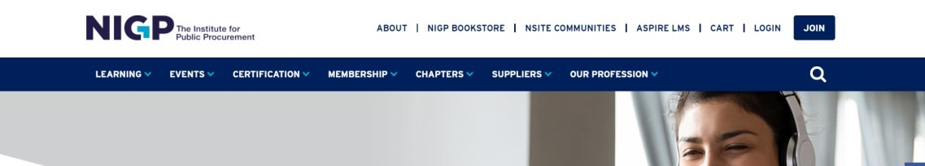

- If you have an account already established, you can login. If you do not have an account, click on “Set up online access” and complete the process. Once you have an account you will be able to login.
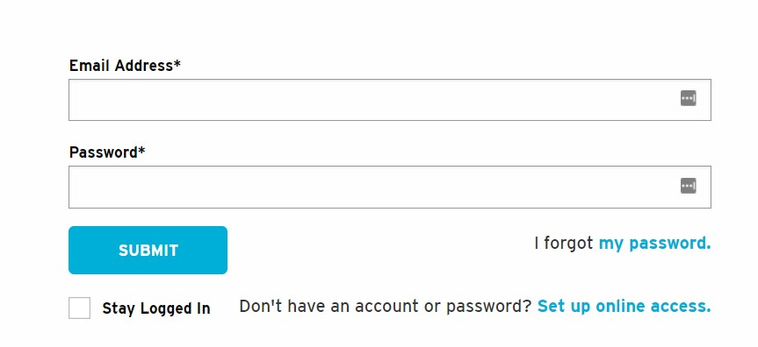

- Once logged in hover over the “Learning” category then hover over the “Webinar” section and select “Webinar Recordings”
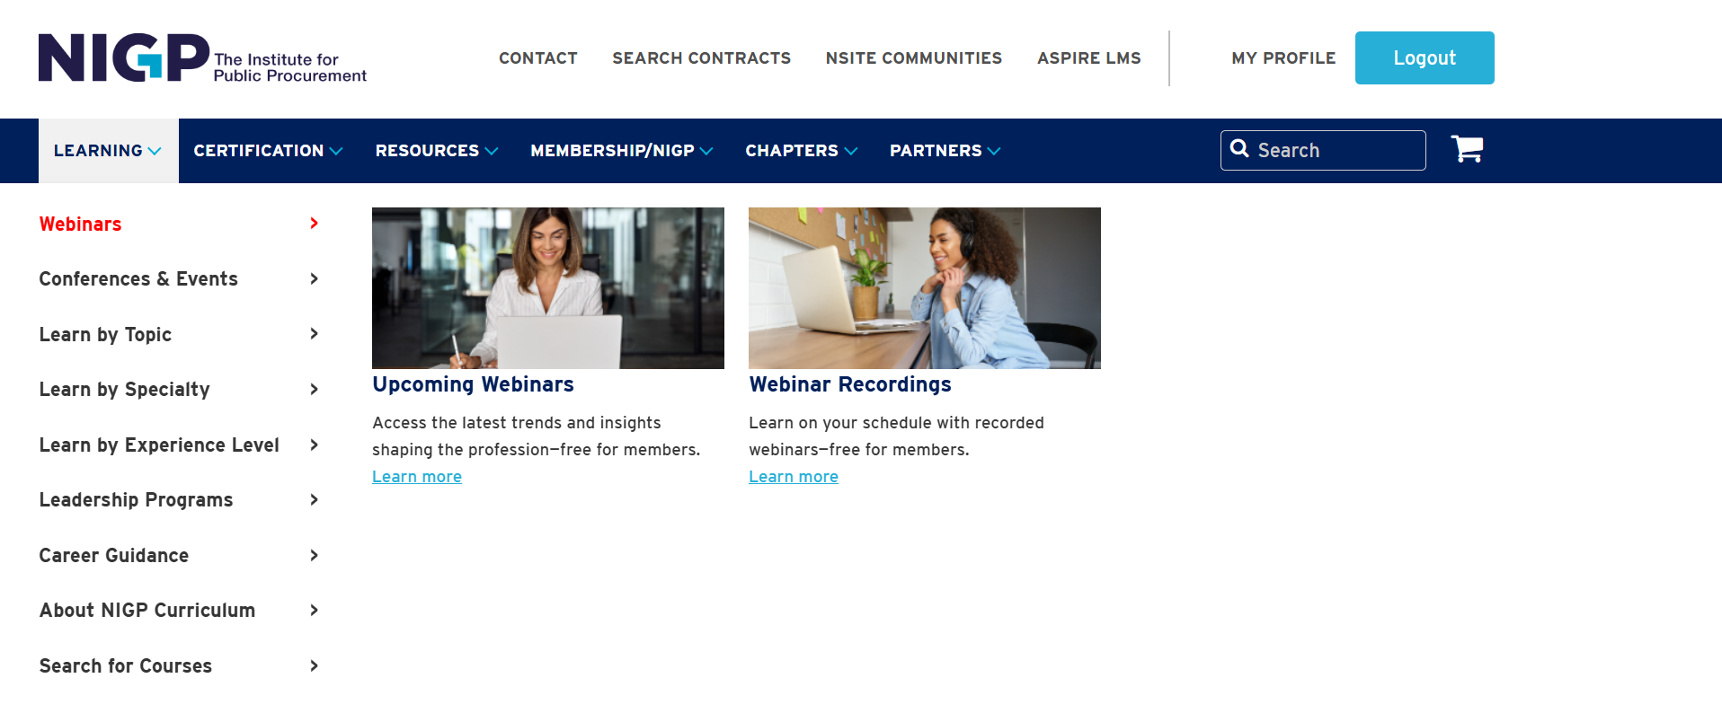

- This takes you to the webinar recordings catalog. Click the + to expand the selection based on each webinar category. Click on the webinar recording title to register. Then click on “Individual Registration” to complete the event registration checkout process.
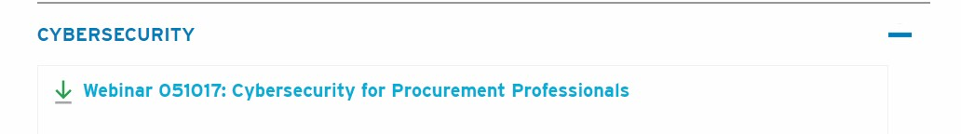

- When you get to the checkout page, please select if you are a member of your local NIGP chapter. Once your chapter is selected, please select the $30 TX fee. After your fee is selected please finish the checkout process.
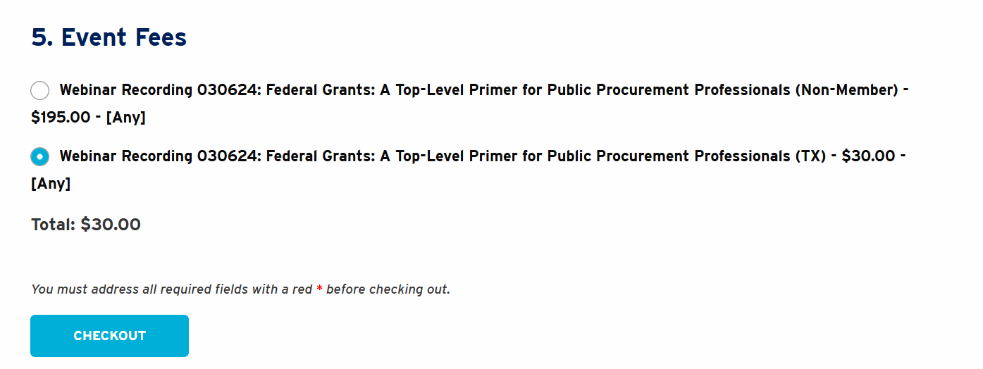

- Once you finish the checkout process. Click on the “ASPIRE LMS” link at the top of the NIGP webpage.
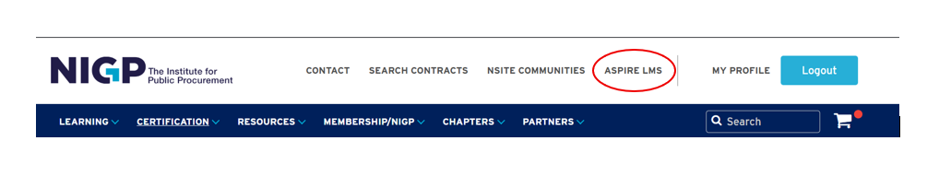

- From the ASPIRE landing page, click on “Go to your Learning Center” and locate the webinar recording you would like to view.
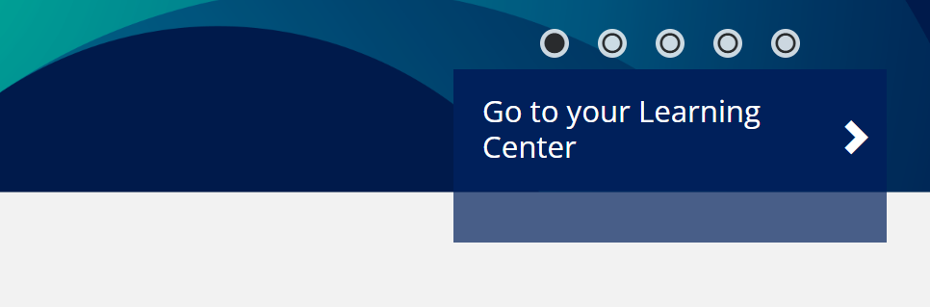

- If your webinar has not loaded into your Aspire Learning Center yet, please click the “Sync Latest Data” button under the current tab.
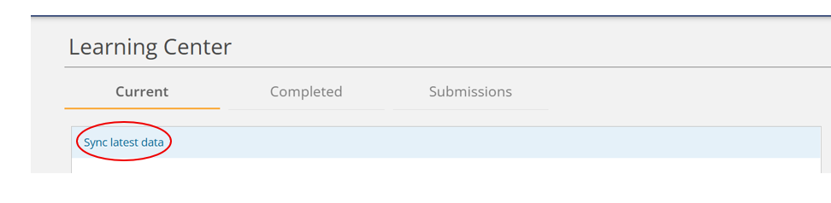
- Click on the webinar name to take you to the webinar recording home page. If you click on the “Launch” button this will auto play the recording.
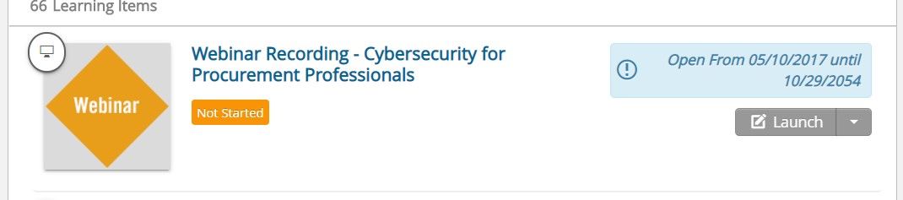

- From the webinar recording homepage, click on the webinar recording name link.
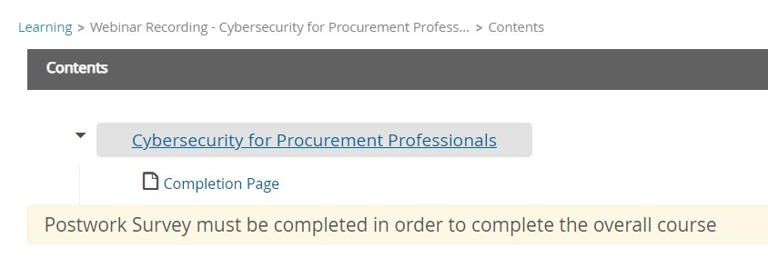
- This will open the video recording. Click play to view. You can also download the presentation slides on this page. Once you finish watching the recording click on “Next.”
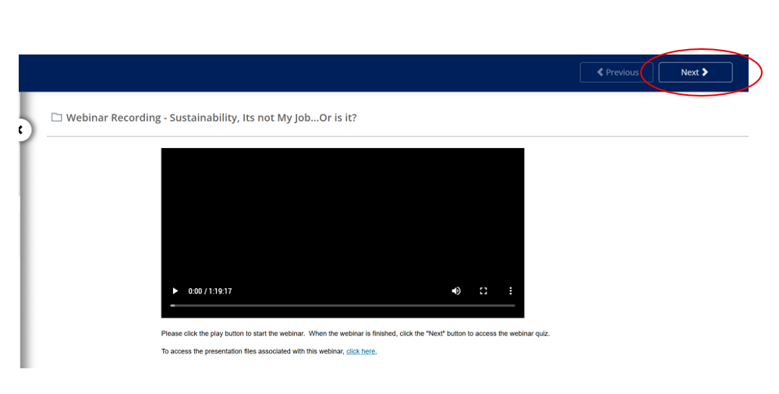

- Complete the brief quiz, then click “Submit”
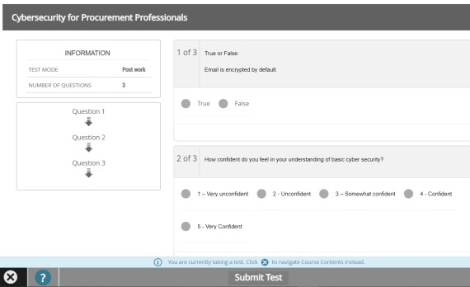

13.

If you successfully completed the quiz, you will gain 1 contact hour of credit. The certificate
of completion can be found under your “Completed” section in your Learning Center. Click “View Certificate” to download or print your certificate.
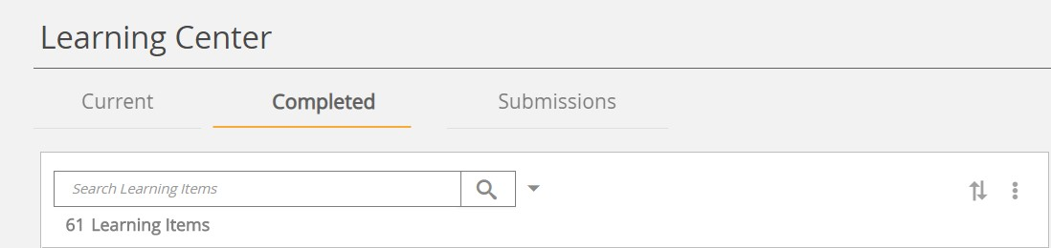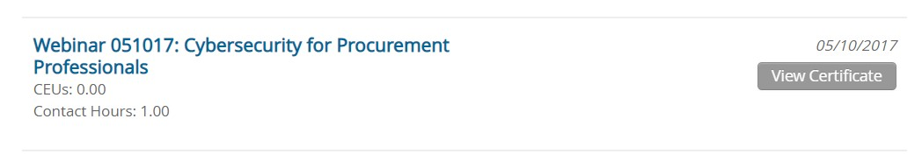

If you happen to run into any issues, please contact distancelearning@nigp.org

